LABORATORY REPORT

**Application Development Lab**

**(CS33002)**

**B.Tech Program in ECSc**

Submitted By

**Name:- ANUBRATA MUKHOPADHYAY**

**Roll No:** 2230311



**Kalinga Institute of Industrial Technology**

**(Deemed to be University)**

**Bhubaneswar, India**

Spring 2024-2025

**Table of Content**

|  |  |  |  |  |
| --- | --- | --- | --- | --- |
| **Exp No.** | **Title** | **Date of**  **Experiment** | **Date of**  **Submission** | **Remarks** |
| 1. |  |  |  |  |
| 2. |  |  |  |  |
| 3. |  |  |  |  |
| 4. | Conversational Chatbot with PDF | 28/01/25 | 09/02/25 |  |
| 5. |  |  |  |  |
| 6. |  |  |  |  |
| 7. |  |  |  |  |
| 8. |  |  |  |  |
| 9. | Open Ended 1 |  |  |  |
| 10. | Open Ended 2 |  |  |  |

|  |  |
| --- | --- |
| **Experiment Number** | 4 |
| **Experiment Title** | Conversational Chatbot with Any Files |
| **Date of Experiment** | 28/02/2025 |
| **Date of Submission** | 09/02/2025 |

1. **Objective:-** To build a chatbot capable of answering queries from an uploaded PDF Document.
2. **Procedure:-**
3. Integrate open-source LLMs such as LLama or Gemma from Ollama
4. Develop a Flask backend to process the PDF/word/excel content.
5. Implement Natural Language Processing (NLP) to allow queries. You can use LLamaIndex or Langchain or Groq API.
6. Create a frontend to upload document files and interact with the chatbot, just like ChatGPT.
7. **Code:-**

Githublink: [AD-LAB-Files/Experiment-4](https://github.com/diptarkasarkar/AD-LAB-Files/tree/main/Experiment-4)

App.py code:

from flask import Flask, render_template, request, jsonify

import os

from PyPDF2 import PdfReader  # Note the capital PyPDF2

from groq import Groq

app = Flask(__name__)

app.config['UPLOAD_FOLDER'] = 'uploads'

app.secret_key = 'abc'

# Create uploads folder if it doesn't exist

if not os.path.exists(app.config['UPLOAD_FOLDER']):

    os.makedirs(app.config['UPLOAD_FOLDER'])

# Initialize Groq client

groq_client = Groq(api_key="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")

# Test API connection at startup

try:

    test_response = groq_client.chat.completions.create(

        messages=[{"role": "user", "content": "Test connection"}],

        model="mixtral-8x7b-32768",

        temperature=0.1,

        max_tokens=10

    )

    print("✅ Groq API connection successful!")

except Exception as e:

    print(f"❌ Groq API connection failed: {str(e)}")

# Global variable to store PDF content

pdf_content = ""

@app.route('/')

def index():

    return render_template('index.html')

@app.route('/upload', methods=['POST'])

def upload_pdf():

    global pdf_content

    if 'pdf' not in request.files:

        return jsonify({'error': 'No file uploaded'})

    file = request.files['pdf']

    if file.filename == '':

        return jsonify({'error': 'No file selected'})

    if file:

        # Save the file

        file_path = os.path.join(app.config['UPLOAD_FOLDER'], file.filename)

        file.save(file_path)

        # Extract text from PDF

        try:

            reader = PdfReader(file_path)

            pdf_content = ""

            for page in reader.pages:

                pdf_content += page.extract_text()

            return jsonify({'message': 'PDF uploaded and processed successfully'})

        except Exception as e:

            return jsonify({'error': str(e)})

@app.route('/ask', methods=['POST'])

def ask_question():

    global pdf_content

    data = request.json

    question = data.get('question')

    if not pdf_content:

        return jsonify({'error': 'Please upload a PDF first'})

    try:

        response = groq_client.chat.completions.create(

            messages=[

                {

                    "role": "system",

                    "content": f"You are a helpful assistant. Use the following PDF content to answer questions: {pdf_content}"

                },

                {

                    "role": "user",

                    "content": question

                }

            ],

            model="mixtral-8x7b-32768",

            temperature=0.1,

            max_tokens=1024,

        )

        answer = response.choices[0].message.content

        return jsonify({'answer': answer})

    except Exception as e:

        return jsonify({'error': str(e)})

if __name__ == '__main__':

    app.run(debug=True)

**index.html code:**

<!DOCTYPE html>

<html lang="en">

<head>

    <meta charset="UTF-8">

    <meta name="viewport" content="width=device-width, initial-scale=1.0">

    <title>PDF Q&A Assistant</title>

    <script src="https://cdn.tailwindcss.com"></script>

    <link href="https://cdnjs.cloudflare.com/ajax/libs/font-awesome/6.0.0/css/all.min.css" rel="stylesheet">

</head>

<body class="bg-gray-900 text-white min-h-screen flex flex-col">

    <div class="bg-gray-800 w-full h-screen shadow-lg flex flex-col p-6">

        <h1 class="text-3xl font-bold text-center text-white mb-6">PDF Q&A Assistant</h1>

        <div class="flex flex-col flex-grow overflow-y-auto p-4 space-y-3 bg-gray-700 rounded-lg" id="chat-box">

            <div class="text-gray-400 text-sm text-center">Start a conversation</div>

        </div>

        <div class="mt-4 flex items-center gap-3">

            <input type="file" id="pdfFile" accept=".pdf" class="hidden" onchange="uploadPDF()">

            <label for="pdfFile" class="bg-blue-600 text-white px-4 py-2 rounded-lg cursor-pointer hover:bg-blue-700 transition flex items-center gap-2">

                <i class="fas fa-file-pdf"></i> Upload PDF

            </label>

            <input type="text" id="question" placeholder="Type a message..." class="flex-grow bg-gray-600 text-white p-2 rounded-lg focus:ring-2 focus:ring-blue-400">

            <button onclick="askQuestion()" class="bg-blue-600 text-white px-4 py-2 rounded-lg hover:bg-blue-700 transition flex items-center gap-2">

                <i class="fas fa-paper-plane"></i>

            </button>

        </div>

    </div>

    <script>

        function appendMessage(content, isUser = true) {

            const chatBox = document.getElementById('chat-box');

            const msgDiv = document.createElement('div');

            msgDiv.className = `flex items-center gap-2 p-3 rounded-lg max-w-[75%] ${isUser ? 'bg-blue-600 self-end' : 'bg-gray-600 self-start'}`;

            const icon = document.createElement('i');

            icon.className = isUser ? 'fas fa-user-circle text-2xl' : 'fas fa-robot text-2xl';

            const textSpan = document.createElement('span');

            textSpan.textContent = content;

            if (isUser) {

                msgDiv.appendChild(textSpan);

                msgDiv.appendChild(icon);

            } else {

                msgDiv.appendChild(icon);

                msgDiv.appendChild(textSpan);

            }

            chatBox.appendChild(msgDiv);

            chatBox.scrollTop = chatBox.scrollHeight;

        }

        async function uploadPDF() {

            const fileInput = document.getElementById('pdfFile');

            if (!fileInput.files[0]) return;

            appendMessage('📄 PDF uploaded', true);

            const formData = new FormData();

            formData.append('pdf', fileInput.files[0]);

            await fetch('/upload', { method: 'POST', body: formData });

        }

        async function askQuestion() {

            const question = document.getElementById('question').value;

            if (!question.trim()) return;

            appendMessage(question, true);

            document.getElementById('question').value = '';

            const response = await fetch('/ask', {

                method: 'POST',

                headers: { 'Content-Type': 'application/json' },

                body: JSON.stringify({ question })

            });

            const result = await response.json();

            appendMessage(result.answer || 'Error processing question', false);

        }

    </script>

</body>

</html

1. **Results/Output:-**

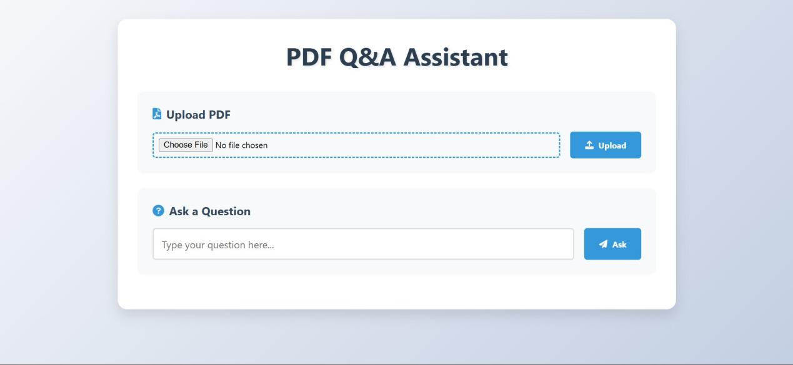

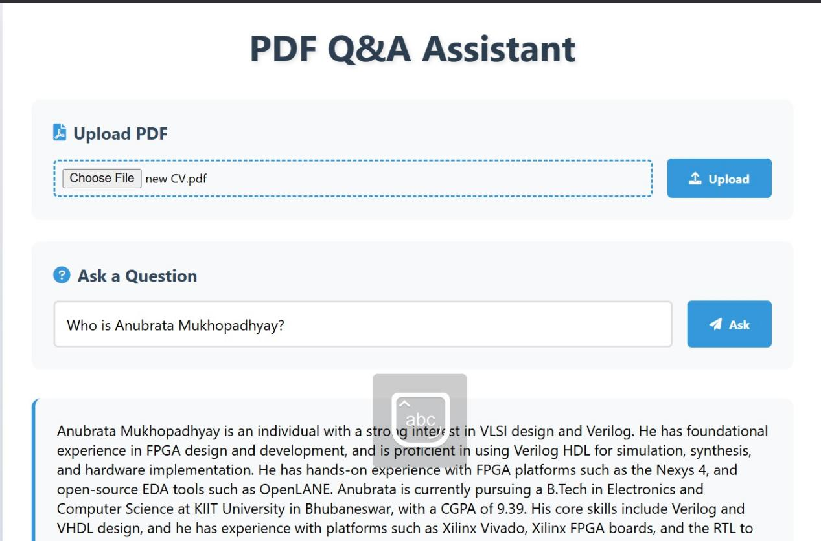

1. **Remarks/Conclusion:-** In this experiment, we successfully developed a conversational chatbot capable of answering queries from uploaded PDF, Word, and Excel documents. By integrating open-source LLMs (Llama/Gemma) or Groq API with a Flask backend and NLP tools like LlamaIndex or Langchain, we enabled efficient document processing and interaction. The frontend allows seamless file uploads and chatbot communication, with an option to select different LLM models, making the system versatile and user-friendly.

|  |  |
| --- | --- |
| Signature of the Student  ANUBRATA MUKHOPADHYAY  (Name of the Student) | Signature of the Lab Coordinator  _________________________________  (Name of the Coordinator) |